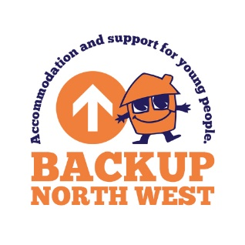
Donations

You can make a difference to a vulnerable young person by donating your unwanted, high quality items to BACKUP. Each time, you are helping a young person who may have arrived at BACKUP with very few personal possessions.

Although we're thankful for all your donations, please be aware that unfortunately there are some items we can't accept:

We can only accept:

Bedding and towels
- new and unused towels, linens, duvets and pillows, in the original packaging
- single bed sizes only
Clothing and footwear
- all clothing and footwear must be new and unused
Furniture
- We have quite specific needs regarding furniture, so please contact our Business Support Team to discuss what you want to donate.
Electrical items
- all electrical items will receive PAT testing
Food and toiletries
- we can only accept non-perishable food items (tins etc)
- No fresh food
- All food and toiletries must be in date

As a rule of thumb, your donations should also be worth buying – if you wouldn’t buy it then we probably won’t be able to pass it one of our young people.

If you have a donation that you feel we will accept, please drop it off at our office at:
Bridgeman House
77 Bridgeman Street
Bolton
BL3 6BY
during office hours only.

Please note, where we receive something that is of exceptional quality –an unused designer item, for instance – we may raffle it to raise additional funds.

If you would like to make a monetary donation, here is an idea of how this would make a difference:
£5 – would pay for a meal for a young person at our Loft House Project
£10 – would pay for a weeks electric for a young person
£25 – is enough money for us to buy a start-up pack for a young person
£60 – is enough money for us to fund and emergency overnight stay for a young person
Thank you.

If you’re looking to donate second-hand clothing or furniture items, our Friends Emmaus Bolton would be grateful for them as they have a charity shop on site. You can find more details at https://emmaus.org.uk/bolton/donate-goods/.

