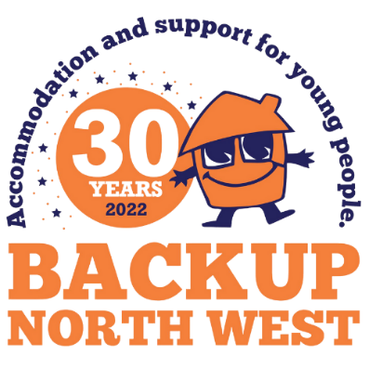

**SKYDIVE FOR**

**BACKUP NORTH WEST**

|  |  |  |  |  |  |  |
| --- | --- | --- | --- | --- | --- | --- |
| |  |  | | --- | --- | | Please sponsor: |  | | To complete the: | Backup Skydive Challenge | | On: | Saturday 6th September 2025 | |



| **Sponsor’s full name** (First Name & Surname) | **Donation**  **amount** **£** | **Date paid** |
| --- | --- | --- |
| Alex Sample | £10 | 24/01/2023 |
|  |  |  |
|  |  |  |
|  |  |  |
|  |  |  |
|  |  |  |
|  |  |  |
|  |  |  |
|  |  |  |
|  |  |  |
|  |  |  |
|  |  |  |
|  |  |  |
|  |  |  |
|  |  |  |
|  |  |  |
|  |  |  |
|  |  |  |
|  |  |  |
|  |  |  |
|  |  |  |
|  |  |  |
|  |  |  |
|  |  |  |
|  |  |  |
|  |  |  |
|  |  |  |
|  |  |  |
|  |  |  |
|  |  |  |
|  |  |  |
|  |  |  |
|  |  |  |
|  |  |  |
|  |  |  |
|  |  |  |
|  |  |  |
|  |  |  |
|  |  |  |
|  |  |  |
|  |  |  |
|  |  |  |
|  |  |  |
|  |  |  |
|  |  |  |
|  |  |  |
|  |  |  |
|  |  |  |
|  |  |  |
|  |  |  |
|  |  |  |
|  |  |  |
|  |  |  |
|  |  |  |
|  |  |  |
|  |  |  |
|  |  |  |
|  |  |  |
|  |  |  |
|  |  |  |
|  |  |  |
|  |  |  |
|  |  |  |
|  |  |  |
|  |  |  |
|  |  |  |

***Copy the form as needed.***

***Donor – please fill in your details***

|  |  |
| --- | --- |
| **Name of Event:** |  |
| **Date:** |  |

|  |  |  |  |  |
| --- | --- | --- | --- | --- |
| ***BACKUP use only:*** | | | | |
| Date received by BACKUP |  | | Date received by Business Support |  |
|  | |  | | |
| Date entered onto Cash / Receipt Book | |  | | |
|  |  | | | |
| Name of Staff |  | | | |

|  |  |  |  |  |  |
| --- | --- | --- | --- | --- | --- |
| First Name: | |  | Surname: |  | |
| Full Address: |  | | | | |
|  |  | | | | |
| Postcode: | | |  | |  |
| Phone Number: | | |  | |  |
| Email Address: | |  | | |

|  |  |  |
| --- | --- | --- |
|  | **Total Donations received** | **£** |
|  | **Date Donations given to BACKUP North West** |  |