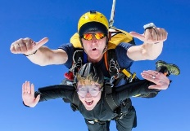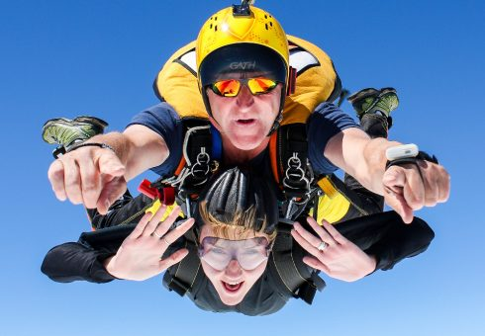**Backup North West**

**Skydive Challenge**

**Saturday 6th September 2025**

**FACT SHEET**

**Some facts taken from the Skydive Northwest Website.**

**What does the jump involve?**

You will be experiencing the thrill of a tandem skydive from 15,000ft, reaching a speeds of up to 120mph. Don’t worry, this is a Tandem jump, meaning you will be harnessed to a professional parachute instructor at all times throughout the descent.

After the rush of freefall, the parachute opens and you’ll experience the tranquillity of flight. No need to worry about making mistakes. The instructor deploys, flies and lands the parachute, leaving you to relax and enjoy stunning views of the Lake District.

This jump is much less demanding than the traditional ‘static line’ jump. A tandem skydive requires only a few minutes training and is the safest and most popular choice for first time skydivers.

**What are the details?**

**When:** Saturday 6th September 2025

From 8:00am - 12pm – Time slots will be allotted to participants.

This will be your **arrival** time, not the jump time.

**How much:** Registration fee: **£70**

Sponsorship: **£350**

**Where:** Skydive NorthWest, Cark Airfield, Moor Lane, Flookburgh, LA11 7LS

We are asking all participants to make their own way to Skydive Northwest centre.

The directions to the centre can be found at [Map & Directions – Skydive Northwest](https://skydivenorthwest.co.uk/directions/).

**What to wear:** All specialist equipment such as helmet, goggles and jumpsuit will be provided. Goggles will fit over glasses and contact lenses are fine. Please wrap up warm, on a hot day t-shirt and trousers/shorts are fine, please wear good fitting trainers. High Heels are not suitable for skydiving!

**What is the criteria?**

For a tandem skydive you must be at least 16 years old and be under 15 stone in weight – please complete the forms enclosed.

Principal medical restrictions are diabetes, epilepsy, fits, recurrent blackouts, heart or lung disease, mental illness and some cases of asthma. You will be required to sign a medical form before your jump declaring your fitness to take part.

Those under the age of 18 will need the medical form signed by a parent or guardian; those with a medical condition will need it signed by their doctor. Pre-existing physical conditions will not necessarily prevent you from taking part but please inform Skydive Northwest of any physical condition as this your jump.

If you are in any doubt, then please contact us for further information.

**Will I be safe?**

Any action sport involves some degree of risk that must be managed. Very strict safety standards are enforced by the British Parachute Association, making serious accidents exceptionally rare for tandem skydivers in the UK.

All activities at Skydive Northwest are regulated by the British Parachute Association. All Tandem Skydive instructors are trained and certified by the British Parachute Association and have already done at least 1000 skydives before becoming an instructor.

We enforce extensive safety procedures to ensure Tandem Skydives are carried out as safely as possible.

**What are the costs involved?**

£200 of your sponsorship should be paid to Backup Northwest 2 weeks before your jump by **Saturday 23rd August 2025**. If you raise your sponsorship through JustGiving this will be done automatically.

The jump costs £270 per participant which is paid directly to Skydive North West. Your £70 is a registration fee and secures your spot on the plane (this is included in the £270 cost of the jump). The remainder will help us to continue our work preventing youth homelessness and forging brighter futures for our young residents. The more you raise the more support we can give to those in need.

**How do I pay my sponsorship?**

You can pay your sponsorship in the following ways:

**By cheque to**: Backup Northwest **Bacs**: Cooperative Bank

Bridgeman House Sort code: 08-90-18

77 Bridgeman Street Acc no: 70966608

Bolton BL3 6BY

Please put ‘Skydive - *your name’* as the reference

**All money raised on Just Giving will automatically be sent to Backup, so you don’t need to worry about sending it over to us.**

**Friends, family and facilities**

Friends and family are welcome, they can watch the skydive and be there to congratulate you upon landing. Skydive North West has the following facilities available:

* Toilets including a disabled toilet
* Shower block available for your use
* A small café onsite - serving hot & cold food (please note they only accept cash)

**Can I get pictures and DVDs?**

Your skydive can be filmed for an additional £95, payable on the day to Skydive North West.

Your very own skydiving cameraman will capture:

* Your pre-jump excitement
* The journey in the plane
* The skydive itself including the free-fall, landing and your post landing reactions.

It’s a great souvenir and a wonderful way of showing friends and family what you have achieved.

**Skydive North West**

**Long Established:** Skydive Northwest is one of the longest established skydiving centres in the UK, taking pride in providing skydiving experiences for over 40 years!

**Modern & Fast Plane:** Our staff are professional and friendly and our aeroplane is modern, fast and specifically made for skydiving.

**Spectacular Views:** With spectacular views across the Lake District, Lake Windermere and Morecambe Bay, Skydive Northwest is one of the most picturesque skydive centres in the world.

**What are the next steps?**

Here is a checklist of all the documents you will need to complete:

* Form 115A- Self-Declaration
* Form 115B – Medical certificate - only required if you have a medical condition listed on from 115A
* Form BPA British Skydiving

Please complete the forms and return to [fundraising@backup-charity.org.uk](mailto:fundraising@backup-charity.org.uk)

Now you can get started on your fundraising journey. The welcome pack includes a sponsorship form and if you need any help getting creative with fundraising ideas then please don’t hesitate to get in touch.

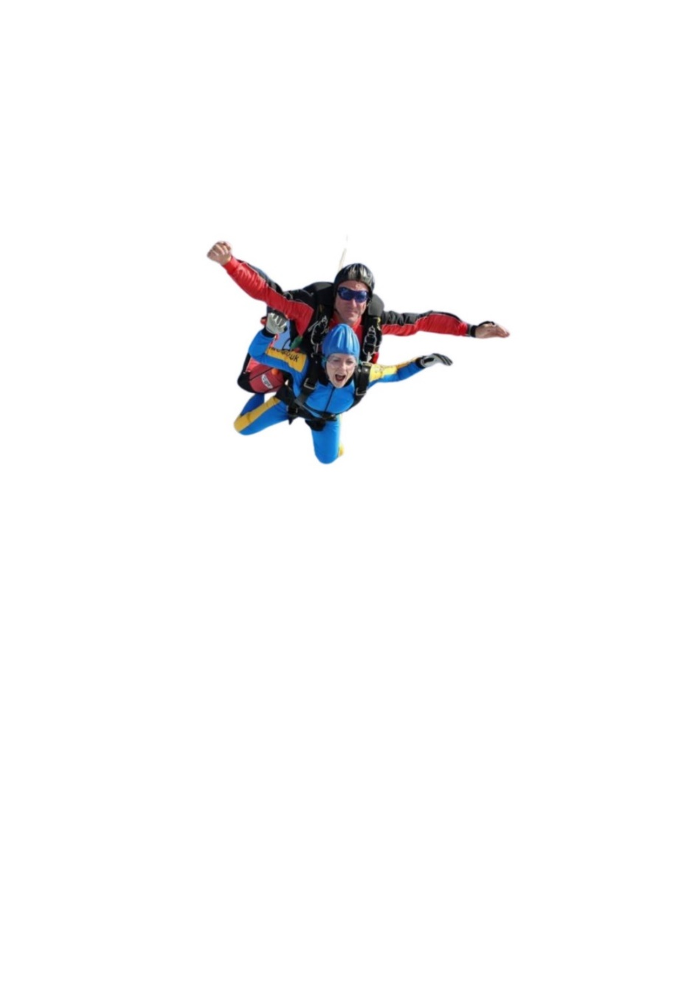**Good luck and thank you from everyone at Backup Northwest, we hope you have the thrill of your life**!

**Terms and Conditions**

1. **Registration**

Only registered participants may take part in BACKUP Skydive 2023. There is a registration fee of **£70 secure your place. The registration fee is non-refundable.**

1. **Fundraising pledge**

You must raise a further minimum of £350 to take part.

1. **Personal health**

It is your responsibility to ensure that you are healthy enough and meet the criteria to take part in the skydive. If in doubt, please take advice from your medical practitioner.

1. **Age limits**

Under 16’s may not participate. There is no maximum age limit but participants over 65 should seek advice from their medical practitioner.

1. **Personal belongings**

BACKUP accepts no responsibility for loss or damage to your personal belongings during the event. We strongly advise you not to bring valuables or delicate technology.

1. **Weather conditions**

Should the weather be unsuitable for jumping on the day it will be up to the jumper to return to the parachute centre on another occasion(s) if necessary to complete their jump.

1. **Media consent**

By registering for the BACKUP Skydive 2025, you give permission to use your name, photograph, voice or likeness, in any broadcast, telecast, advertising promotion, or other account of this event, or marketing or promotion for future or similar events. If you don’t want to be in any photos just let us know, that’s fine.

1. **Data protection**

BACKUP will process your personal details for the purposes of the Skydive 2025. We would love to keep you informed about our work, if you would prefer not to hear from us following the event, please inform us by emailing [laurapendlebury@backup-charity.org.uk](mailto:laurapendlebury@backup-charity.org.uk)

1. **Cancellation**

BACKUP reserves the right to cancel or alter the event without notice. Also if in the event of extreme adverse weather alternative arrangements will be made.