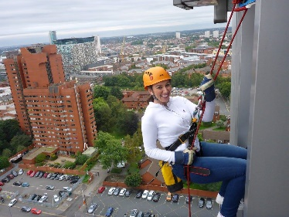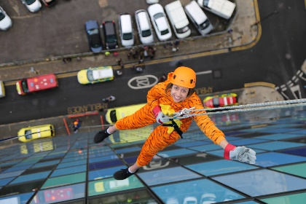**Backup North West**

**Abseil Challenge**

**Saturday 15th April 2023**

**FACT SHEET**

**Some facts taken from the Dolomite Training Website**

**What does the day involve?**

You will be scaling 59 feet down the East side of the University of Bolton Stadium.

You will be guided by the team at Dolomite every step of the way.

**What are the details?**

**When:** Saturday 15th April 2023

From 10am - 4pm – Time slots will be allotted to participants.

This will be your **arrival** time, not the abseil time.

**How much:**

Registration fee:

**£30** for 18 and over

**£25** for under 18s

Sponsorship: **£200** minimum

**Where:** Car Park A,De Havilland Way, Horwich, Bolton BL6 6SF

We are asking all participants to make their own way to the University of Bolton Stadium for their arrival time.

**What is the criteria?**

For this abseil you must be:

* 8 years and older. Anyone under the age of 18 will need to be accompanied by a parent/guardian.
* Maximum age 80 years old
* 110kg or 17 stone and under

If you have any concerns about your ability to participate due to any medical conditions, then please talk to us in the first place but you may need advice from your GP as we are not medically trained.

**Will I be safe?**

Any activity involves some degree of risk that is managed. Please read the acknowledgment of risk form.

All instructors are qualified to run abseiling and is something they all do on a regular basis.

Safety procedures are in place to ensure abseils are carried out as safely as possible.

**What are the costs involved?**

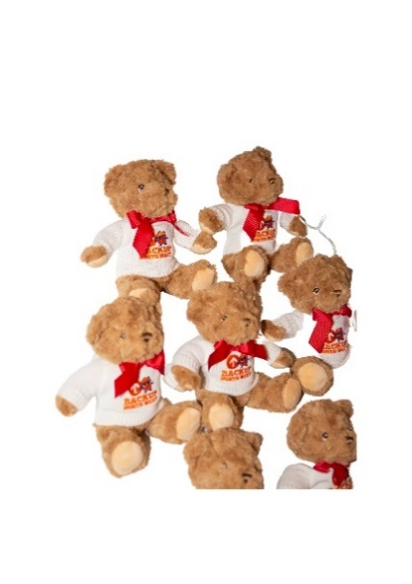You must provide a £25/30 registration fee paid upon sign up to BACKUP North West. Then you are required to raise a minimum of £200 to participate. Every participant that raises £300 and over will receive a limited edition Backup Bear.

£150 of your sponsorship should be paid to Backup Northwest 2 weeks before your abseil and the remaining £50 within one week after the abseil.

BACKUP will provide a Fundraising pack, complete with a sponsorship form for you to raise sponsorships from your friends, family, work colleagues etc.

Your registration fee secures your spot on the abseil and allows us to cover the running costs of the abseil. This allows your sponsorship to go directly to helping our young people in need.

Some young people turn up with nothing but the clothes on their backs, sometimes without a coat, bag or even ID. Your sponsorship will help the young people feel more human and at home.

**The more you raise the more support we can give to those in need.**

**How do I pay my sponsorship?**

You can pay your sponsorship in the following ways:

**By cheque to**: Backup Northwest **Bacs**: Cooperative Bank

Bridgeman House Sort code: 08-90-18

77 Bridgeman Street Acc no: 70966608

Bolton Bl3 6BY

Please put ‘Abseil - *your name’* as the reference

If you only raise funds through Just Giving then you do not need to worry about sending any money to us. Just Giving automatically sends your sponsorship to Backup each month.

**Can I make a Just Giving page and can we get Gift Aid?**

You can also collect donations through a Just Giving page, please may I ask that you join our team page (at [www.justgiving.com/campaign/backupabseil](http://www.justgiving.com/campaign/backupabseil)). Don’t worry everyone still has their own individual page which shows your personal story and progress but it also shows us overall as a team.

As your registration fee covers the running costs this means we are qualified to claim gift aid on this challenge, so please do allow Gift Aid when setting up your page, as it is a great way to raise additional funds at no extra cost to the donor.

The money donated on Just Giving goes directly to Backup, so you don’t need to worry about sending it over to us

**Friends, family and facilities**

Friends and family are welcome to come along on the day to watch.

We will have a radio DJ on site to provide music and entertainment throughout the day as well as a food and drink van.

There is free parking onsite at the football stadium, the closest car park to the abseil is Car Park A.

There will be toilets available for all to use including disabled access.

**Can I get pictures?**

Your family and friends are welcome to take pictures of you from the ground below.

We will have a photographer onsite who will capture the whole day. The photos will then be edited and sent to us in the following days which you can access free of charge.

**What are the next steps?**

Here is a checklist of the next steps you need to take

* Register for your place
* Create your Just Giving Page
* Start your fundraising
* Read the Acknowledgment of risk form (below). You will need to sign to say you have read this when you check in at the abseil.
* For individuals under 18, you will need a parent/guardian to sign the consent form when you check in at the abseil.

Now you can get started on your fundraising journey. The welcome pack includes a sponsorship form and if you need any help getting creative with fundraising ideas then please don’t hesitate to get in touch.

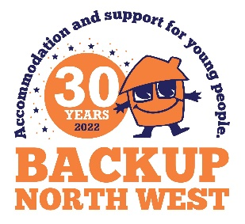**Good luck and thank you from everyone at Backup Northwest, we hope you have a great abseil!**

**Terms and Conditions**

1. **Registration**

Only registered participants may take part in BACKUP Abseil 2023. There is a registration fee of £25 or £30 secure your place. The registration fee is non-refundable.

1. **Fundraising pledge**

You must raise a further minimum of £200 to take part. There will be a prize for every participant that raises £00 and over.

1. **Personal health**

It is your responsibility to ensure that you are healthy enough and meet the criteria to take part in the abseil. If in doubt, please take advice from your medical practitioner.

1. **Age limits**

Under 8’s may not participate. Anyone under the age of 18 will need to be accompanied by a parent/guardian. The maximum age is 80 but participants over 65 should seek advice from their medical practitioner.

1. **Personal belongings**

BACKUP accepts no responsibility for loss or damage to your personal belongings during the event. We strongly advise you not to bring valuables or delicate technology.

1. **Weather conditions**

The weather will be checked in the days leading up to the event. Any decisions to cancel this event will be taken by the event organisers. Dolomite Training will advise on this from a safety point of view. No abseil has yet been cancelled although some have been paused during an event to allow heavy rain to pass through. If this happens, then this may cause a delay in your timed slot.

1. **Media consent**

By registering for the BACKUP Abseil 2023, you give permission to use your name, photograph, voice or likeness, in any broadcast, telecast, advertising promotion, or other account of this event, or marketing or promotion for future or similar events. **If you don’t want to be in any photos just let us know, that’s fine.**

1. **Data protection**

BACKUP will process your personal details for the purposes of the Abseil 2023. We would love to keep you informed about our work, if you would prefer **not** to hear from us following the event, please inform us by emailing [fundraising@backup-charity.org.uk](mailto:fundraising@backup-charity.org.uk)

1. **Cancellation**

BACKUP reserves the right to cancel or alter the event without notice. Also if in the event of extreme adverse weather alternative arrangements will be made.

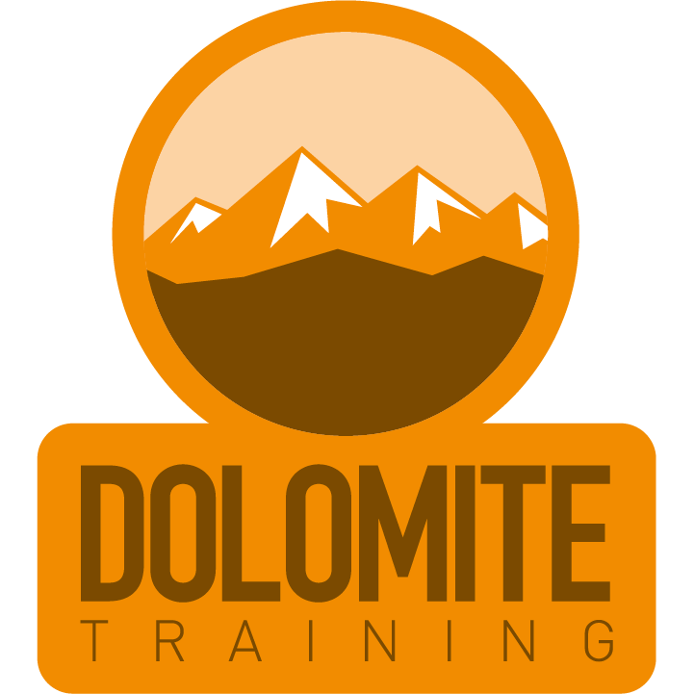

**Outdoor Activity Acknowledgement of Risk**

I understand that outdoor adventurous activities including abseiling, may be physically,

mentally and emotionally challenging. I accept that there are inherent risks associated with

this type of activity.

I understand the following:

• I must inform Dolomite staff of any health or medical issues that may affect my ability to participate in these activities safely. **This includes symptoms of Covid 19**.

• The environment that the activities take place has man made and natural hazards and risks.

• I accept that I need to take responsibility for myself and others whilst on any activity with Dolomite Training.

• I must at all times follow the safety instructions and ensure that all safety equipment is being used correctly. If I do not adhere to the instructions given by Dolomite staff there is a risk of injury that could be fatal.

• If I do not understand the instructions or I become confused about the instructions I will ask for help from Dolomite staff.

• Dolomite staff reserves the right to stop an activity with no refund if they deem you to be unsafe or unfit to participate.

Dolomite Training Ltd – www.dolomitetraining.co.uk – info@dolomitetraining.co.uk