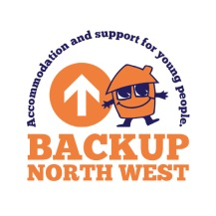

**Supported Lodgings Provider – Onboarding Process**